OSTEOPOROSIS
Diagnosis Recommendations
Bone mineral density testing is recommended for individuals over age 50 years with at least one major risk factor or two or more minor risk factors. Everyone over the age of 65 years should have a bone mineral density test.
Risk Factors for Osteoporosis

Major risk factors | Minor risk factors
Age >65 years | Rheumatoid Arthritis
Vertebral compression fracture | Past history of clinical hyperthyroidism
Fragility fracture after age 40 | Chronic anticonvulsant therapy
Family history of osteoporotic fracture (especially maternal hip fracture | Low dietary calcium intake (see nutritions section)
Systemic glucocorticoid therapy of >3 months duration | Smoker
Malabsorption syndrome | Excessive alcohol intake
Primary hyperparathyroidism | Excessive caffeine intake (see nutrition section)
Propensity to fall | Weight <57 kg
Osteopenia apparent on x-ray film | Weight loss >10% of weight at age 25
Hypogonadism | Chronic heparin therapy
Early menopause (before age 45)
Average 10-year Probability of an Osteoporotic Fracture*

Dietary Recommendations
Vitamin D daily intake of 800 IU for men and women ages > 50 years. The US RDA continues to be 400 IU, though the literature supports 800 IU for the older adults, though the minimum age for the higher recommendation has not been well established.

Recommended Daily Intake of Calcium
CALCIUM
Prepubertal children (ages 4-8) | 800 mg/day
Adolescents (ages 9-18) | 1300 mg/day
Women (ages 19-50) | 1000 mg/day
Women (ages over 50) | 1500 mg/day
Pregnant and lactating women (ages > 18) | 1000 mg/day
Men (ages 19-50) | 1000 mg/day
Men (ages over 50) | 1500 mg/day
VITAMIN D₃
(Vitamin D₂ shows less potency and more may be required to meet these recommendations)
Women (ages 19-50) | 400 IU (10ug/day
Women (ages over 50) | 800 IU (20ug/day
Men (ages 19-50) | 400 IU (10ug/day
Men (ages over 50) | 800 IU (20ug/day
ADDITIONAL NUTRIENTS
Adequate protein intake is important
Avoid excess caffeine (> 4 cups coffee/day)
Avoid excess dietary sodium (> 2100 mg/day or > 90 mmol/day) as it reduces BMD in adult men and women.
No evidence exists to recommend supplementation with the following nutrients for the prevention or treatment of osteoporosis: magnesium, copper, zinc, phosporus, manganese, iron, essential fatty acids

Treatment Recommendations
Oral bisphosphonates are first-line medications for the prevention and treatment of postmenopausal and glucocorticoid-induced osteoporosis, and in the treatment of men with osteoporosis. Selective estrogen receptor modulator, raloxifene is also a first-line prevention and treatment of postmenopausal osteoporosis.
Intra-nasal calcitonin is second-line treatment because of the lack of efficacy in the prevention of hip fractures in the large-scale clinical trials.
Parathyroid hormone therapy is first-line only for severe osteoporosis.

References: JAMC 167(10 suppl), 2002
Kanis et al. Osteoporosis Int 12:989, 2001.

GUIDELINES FOR THE PREVENTION AND TREATMENT OF GLUCOCORTICOID INDUCED OSTEOPOROSIS

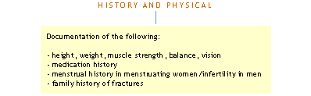
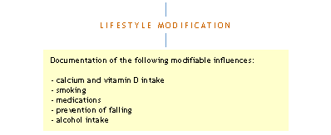
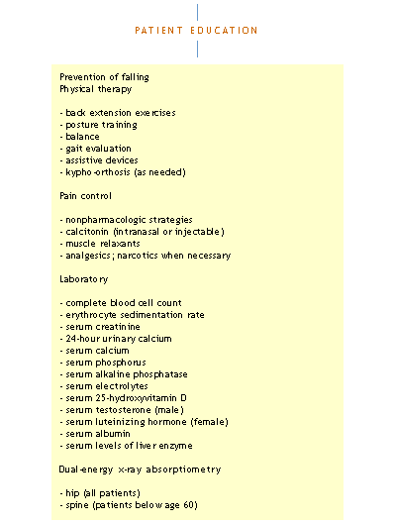

> Follow-up for abnormal laboratory findings

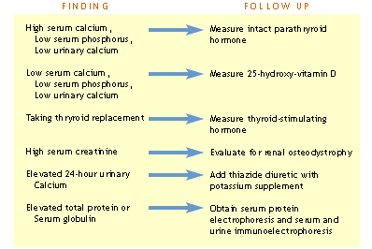

Recommendations for the Prevention and Treatment of Glucocorticoid-Induced Osteoporosis
The following updated recommendations are the result of work by the ACR Ad Hoc Committee on Glucocorticoid-Induced Osteoporosis published in Arthritis Rheum 44(7), 2001.
> Patient beginning therapy with glucocorticoid (prednisone equivalent of > 5 md/day) with plans for treatment duration of > 3 months.
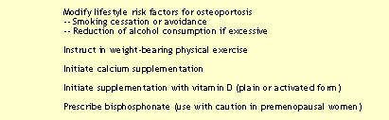

> Patient receiving long-term glucocorticoid therapy(prednisone equivalent of > 5mg/day)
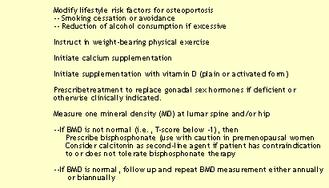

Reference: Recommendations for the Prevention and Treatment of Glucocorticoid-Induced Osteoporosis. Arthritis Rheum 44:1496-1503, 2001.

